Cottontail Drive Thru Station Participant Guidelines
The Peterborough Recreation Department is looking for Easter Bunny helpers to help give out candy, eggs, surprises for this year’s Cottontail Drive Thru Easter Event. We are very excited to offer an Easter event while practicing safe fun for our community. This will be a group effort and to participate we need to be sure these guidelines/recommendations are met.
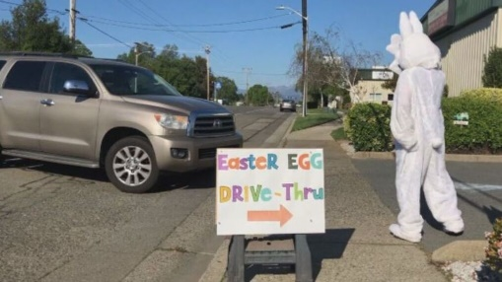
Event Information:
Date: Saturday, March 27th, 2021 (Extreme weather make up will be April 3rd)
Time: 10am-1pm by advanced reservation only
Locations: Peterborough Elementary School (Please enter on High Street!)
17 High Street, Peterborough NH. 03458
Fee: This is a free event.
Who: Reserve a station to distribute Candy/Eggs/Surprises no later than Friday, March 12th.
Space is limited so reserve your spot now.
How to register: Please email John at jkohlmorgen@peterboroughNH.gov to express your interest in participating. We will need your name, phone number, email address, the basic theme of your station as well as a description of how you plan to distribute your treats to participants in the cars while maintaining at least 6 feet of social distancing. You may also call 924-8080 and give us the above requested information.
NOTES:
- If you are not feeling well, have a fever or exhibit any cold like or respiratory symptoms, please stay home. Keep our community safe! Cancel your spot, if necessary, by calling John Kohlmorgen at 603-933-9413.
- All participants at the stations must wear clean face masks for the duration of the event. Make it fun make it part of your costume.
- Attendees are also required to wear clean face masks.
- Theme/decorate your vehicle appropriately, this is what it is all about…decorating your vehicle/station and being unique and standing out. We need cars stations and table stations so please let John know which station you would like to be. If you can please provide your own table that would be a huge help. Volunteer time arrive at station at 9:30am Depart 1:30pm.
- Handouts: Station participants provide their own candy/Eggs/goodie bags/Surprises. No unwrapped candy or loose edible items, such as fruits, allowed. Everything must be sealed and not opened.
- Again, create a unique and fun way of getting the kids their treats from 6 feet away.
- There is no electricity for blow up/extra props or extra lights for your station. Please bring a generator if you are interested in bringing blow up/extra props or extra lights.
Other Note: We are planning/preparing for 500 kids via 150 possible cars reservations. However, we could possibly have more children. If you would like to have extra candy/eggs/surprises on hand - just in case -that would be great. If not, when you run out of candy you are done for the day and free to go. We will give you an update as to all anticipated numbers the Monday (2/22) & Friday (2/26) before the event.
THIS EVENT WOULD NOT BE POSSIBLE WITHOUT OUR VOLUNTEERS AND PARTICIPANTS.
THANK YOU FOR SUPPORTING PETERBOROUGH RECREATION DEPARTMENT AND
THE PETERBOROUGH COMMUNITY!

